I’m Emily from Class 20,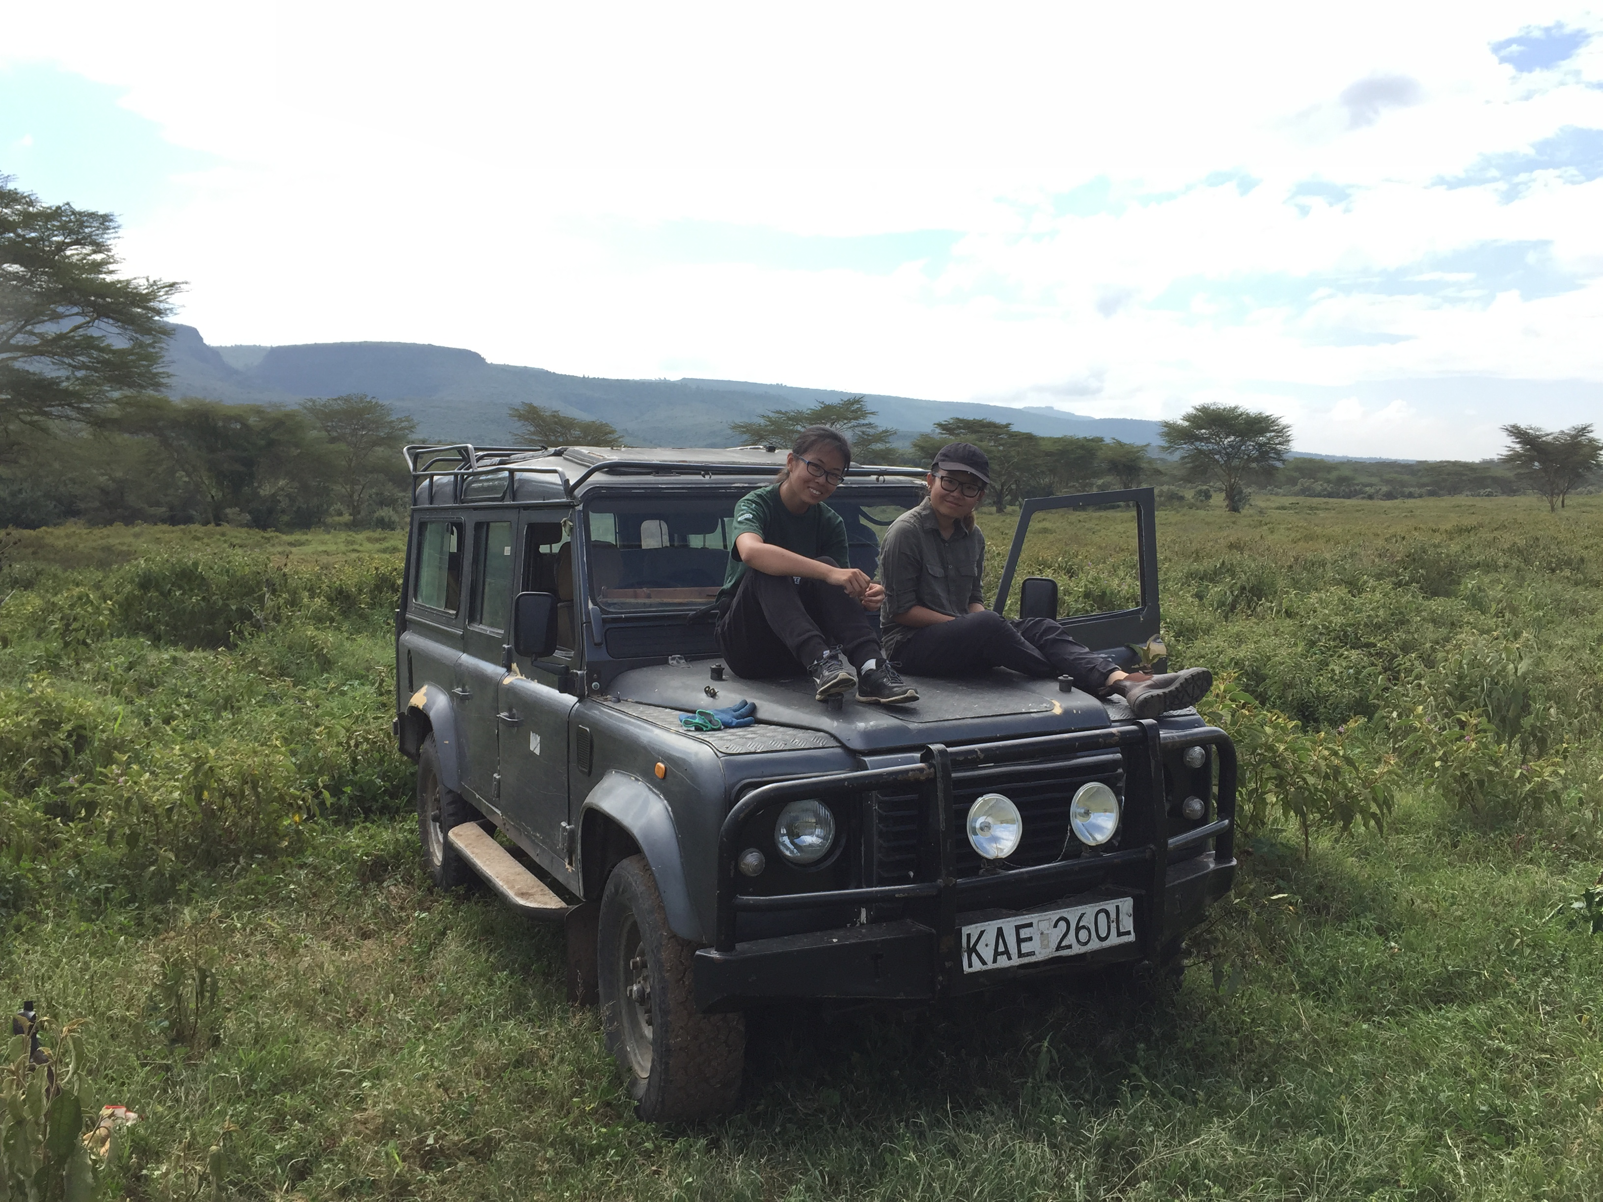 Senior 2. I like to travel, especially to the so-called “third world,”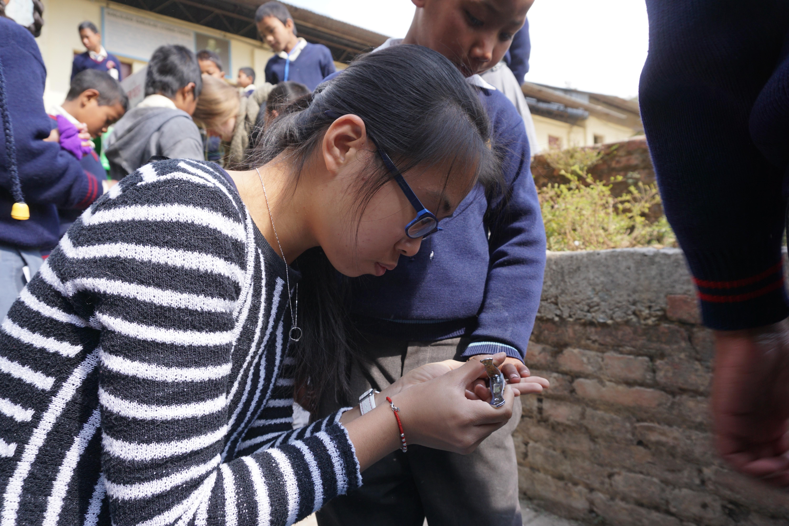 and do volunteer work. In my spare time, I enjoy practicing the guzheng, solving Rubik’s Cubes and translating and writing articles. My dream is to participate in Doctors Without Borders and hopefully become a social worker in Africa. I’d like to share my experience of volunteering in other countries because these events have been a major part of my high school years.

During my sophomore year, I went to Nepal. While I was there, I observed medical procedures and doctors’ rounds in the physiotherapy and ICU departments of a poor, local hospital and taking care of children from a local primary school. This last winter break, I volunteered at a conservancy in Kenya. I spent my time there helping researchers collect data on wildlife and contributing to the upkeep of the conservancy.

Nepal is a magical country with a rich culture and lovely people. I liked the temples which located in every corner of Kathmandu, the catchy music and the colorful, traditional dresses. Aside from the medical knowledge that I gained and the new friendships that I made there, what really left a deep mark on me was the trust I developed with a three-year-old boy whom I took care of for three weeks. He had a heart issue since he was born and was about to have his third surgery the day I left. He was shy and unwilling to share anything with me. But I read books to him and taught him English, drew pictures with him and brought fruit for him everyday. Gradually, he shared his books and pencils with me, and entrusted me with his feelings. On my last day, he was waiting for me at the front door of the hospital’s nutrition center. He grabbed my hands and dragged me to the backyard. With a bit of fear but a lot of trust and expectation, he looked straight into my eyes and asked eagerly, “will you come back?” As I burst into tears, the director of the nutrition center came out, hugged me, and whispered in my ear that Nepal was magical. She told me that none of the volunteers that came ever wanted to leave, and they always came back.

Though I haven’t gotten a chance yet to go back to Nepal, I did go on another program, to Kenya. Other volunteers and I lived in a small, quiet camp located in the middle of Kigio Wildlife Conservancy. We worked as a team to protect wildlife in the conservancy, and conducted a lot of hard work such as repairing roads and monitoring electricity supply for electric fences surrounding the conservancy. I was exhausted every evening, and had bruises all over my body. However, I enjoyed working with friends. We could literally laugh all day about everything that happened. My favorite experience was the night survey we did on my last night. We drove around the conservancy and saw a lot of animals that we usually didn’t see during the daytime like rabbits, hyenas and leopards. While sitting in the car with the sunroof open, we gazed up at the stars in the sky, chatting with each other and feeling proud that did our part to protect the wildlife and environment at Kigio.

Working as a volunteer and traveling around is more than just witnessing new sights and trying new things. Not only do I develop friendships and collect stories to tell, I also become a more mature and independent person from each trip. I feel more grateful to my family because of their support and, more importantly, I realize that I need to give back to society in order to feel satisfied with my life. As J.K.Rowling said during her 2008 commencement speech at Harvard, “we don’t need magic to change the world, we carry all the power we need inside ourselves already: we have the power to imagine better”. Using “my power to imagine better,” I hope to continue working as a volunteer and making this world a better place.